* Make a folder with name as "Sports"

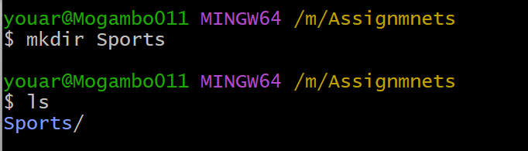

* Initialize git in this folder

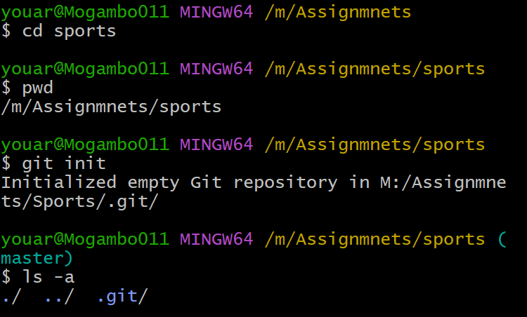

* Make three folders cricket, badminton and football

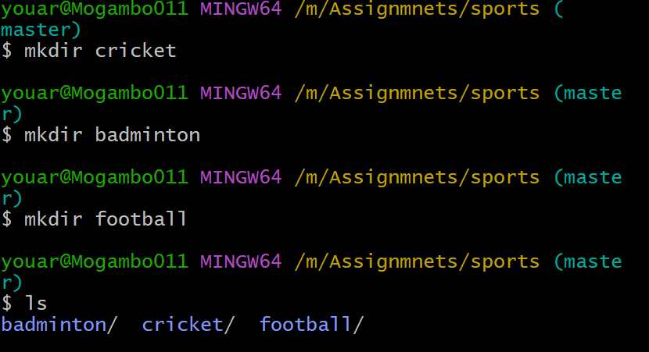

* Make a txt file in all the above mentioned folders and mention which sports uses which equipment's

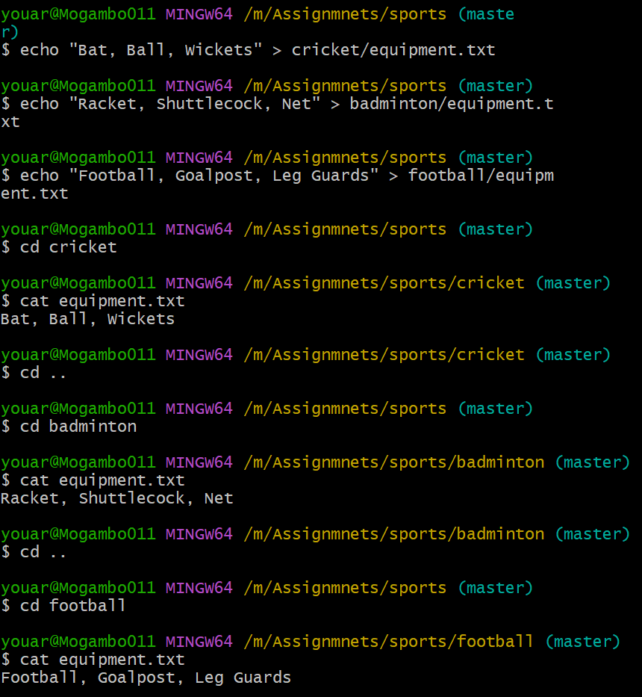

* Check git status

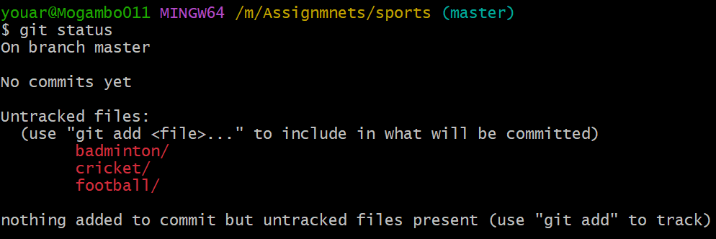

* Add all changes to staging are

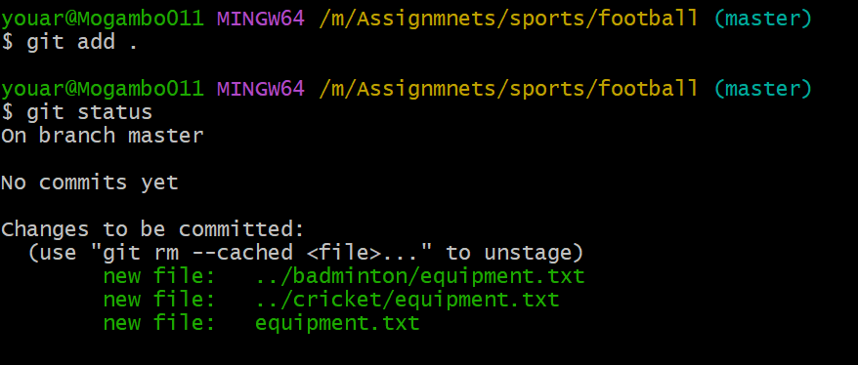

* Commit all changes

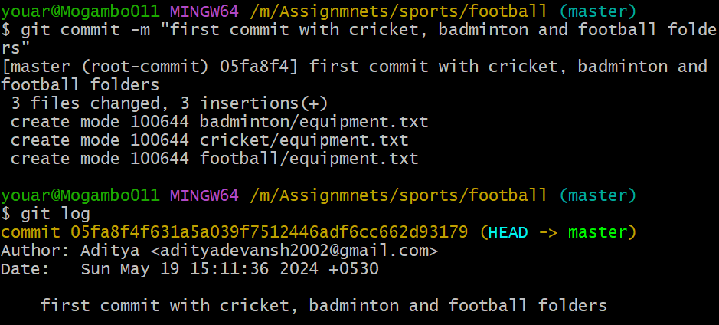

* Push your code to a GitHub

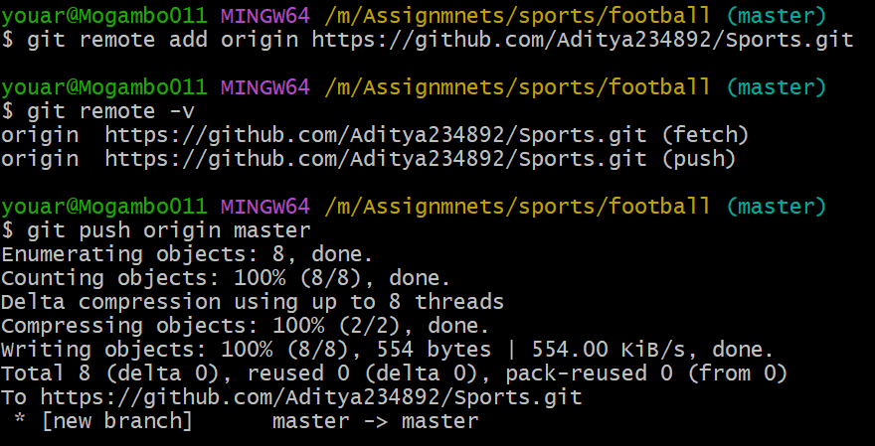

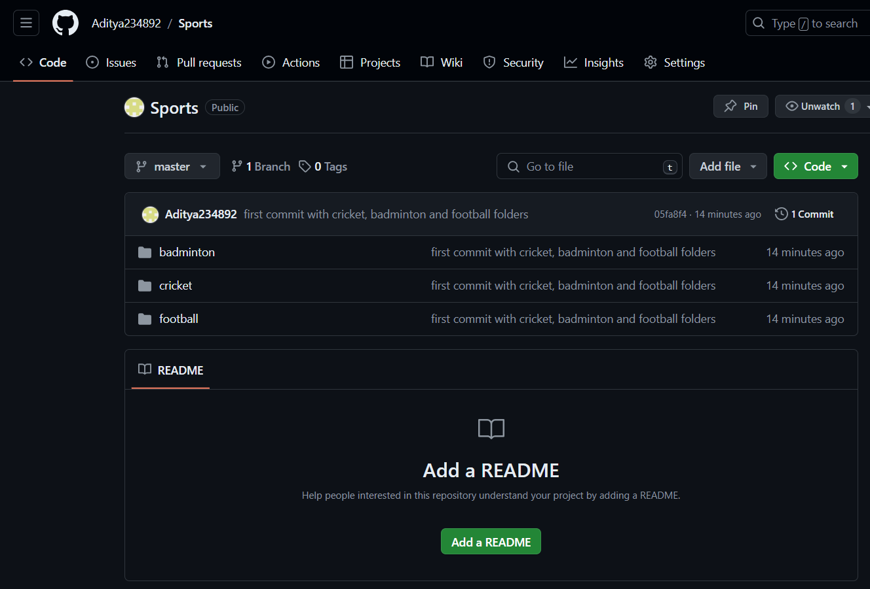

* Add a new folder names as hockey in your main folder (Sports)

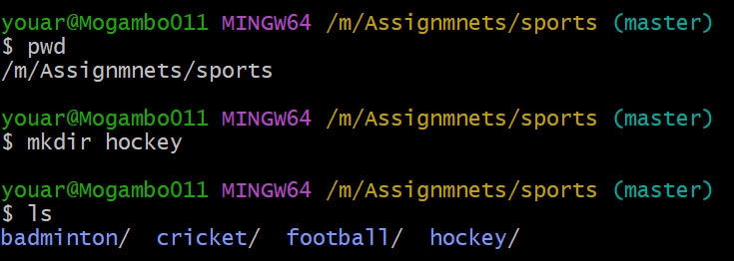

* Make a txt file and mention which equipment's are used in hockey

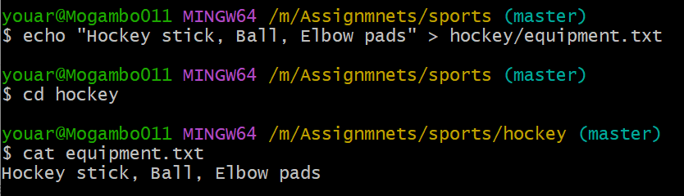

* Also remove football folder

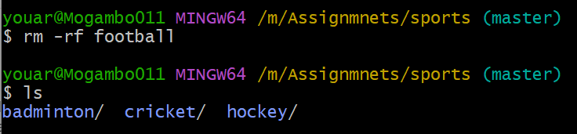

* Add all changes to staging area

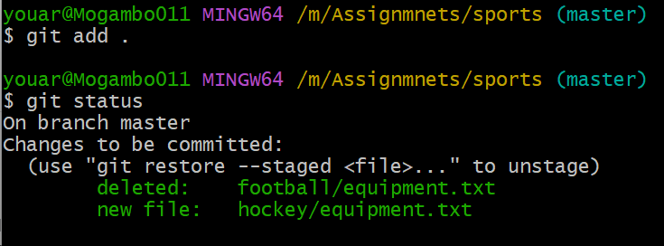

* Commit all changes

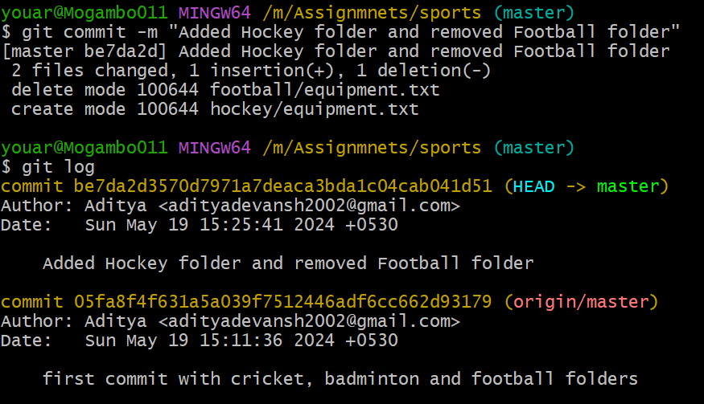

* Push your code to a GitHub

